**PROJECT REPORT ON LIBRARY MANAGEMENT SYSTEM**

**BACHELOR OF TECHNOLOGY**

**IN**

**COMPUTER SCIENCE AND ENGINEERING**

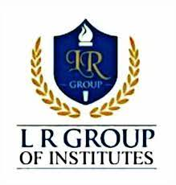

**L.R. Institute of Engineering and Technology, Solan**

**Project Title**: Library Management System

**Company/Institute**: Excellence Technology-Hamirpur(HP)-177022

**Developer**: Ankush Lagwal

Submitted in partial fulfilment of requirements for the award of graduation in **COMPUTER SCIENCE ENGINEERING.**

SUBMITTED TO: Mrs. Ritika **(Asst. Professor)**

SUBMITTED BY: Ankush Lagwal **(5th semester)**

ROLL NO.: **23021503010**

DEPARTMENT OF COMPUTER SCIENCE ENGINEERING

LRET-Solan, Himachal Pradesh-173223

**CONTENTS**

* PROJECT EXECUTION REPORT
* CERTIFICATE
* ACKNOWLEDGEMENT
* STUDENT’S DECLARATION
* COMPANY PROFILE
* PROJECT INTRODUCTION
  + PROJECT TITLE &CATEGORY
  + DEVELOPMENT ENVIRONMENT
  + INTRODUCTION
  + OBJECTIVES OF PROJECT
  + REQUIREMENTS
  + METHODOLOGY
  + GANTT CHART
  + WORKING ENVIRONMENT
* CODING
* SNAPSHOTS
* SCOPE OF THE PROJECT
* BIBLIOGRAPHY

PROJECT EXECUTION REPORT

|  |  |  |  |
| --- | --- | --- | --- |
| Serial no. | Name of phase | Last date | Remarks |
| 1. | Synopsis submission |  | Synopsis submission for approval. |
| 2. | Requirement analysis |  | Analysis of functional operational & technical requirements. |
| 3. | Conceptual design |  | Design of database model. |
| 4. | 1st review |  | Review of all previus phases. |
| 5. | Implementation and test cases |  | Submission of running project and implemention of test cases. |
| 6. | Final review |  |  |

## ****CERTIFICATE****

## 

## ****ACKNOWLEDGEMENT****

Apart from the efforts of me, the success of my project depends largely on the encouragement and guidelines of many others. I take this opportunity to express my gratitude to the people who have been instrumental in the successful completion of this project.

First of all, I would like to express our profound gratitude and thanks to Principal Dr.P.P. Sharma,

L.R. Engineering & Technology, Solan, and then an amazing technophile Mrs. Vandana, Assistant Professor in the Department of Computer Science & Engineering. They provided us with all the guidance and support. They suggested many ideas and solved all our doubts when we were in need. They have provided us with all the guidance & support. They suggested us many ideas and helped us out whenever we were stuck somewhere.

I would like to show my greatest appreciation to my project in-charge, **Mr. Gaurav**. I can’t say thank you enough for the tremendous support and help. I feel motivated and encouraged every time we attend his meeting. Without his encouragement and guidance this project work would not have materialized.

I am highly grateful to **Mr. Gaurav**, Java instructor at Excellence Technology Hamirpur, for his thorough guidance right from day 1 till the end of training. He actually laid the ground for conceptual understanding of technologies used in project.

Ankush Lagwal

## ****STUDENT’S DECLARATION****

I am a student of Computer Engineering of L.R. institutes of engineering and technology Solan. I completed my 28 days of Industrial Training in Core Java from Excellence Technology Hamirpur. Everything I learned they were very important things which gave us a lot of help to improving our programming skill.

## ****COMPANY PROFILE****

* **Excellence Technology**

Excellence Technology is a software development and industrial training company in Chandigarh and Mohali, India. The company was founded by Deepak Kashyap, a senior web developer with experience as a project manager and team lead at other companies.

Excellence Technology is an industrial training company which is engaged in providing computer education in Microsoft Technologies, to students as well as professional executives.

* **Excellence Technology, Hamirpur**
* Excellence Technology is a complete IT solutions providing company based in Hamirpur. Excellence Technology was created to achieve the goal of providing its clients state-of-art web development services comparable with best in the world.
* The services provided by Excellence Technology are
* Web Development
* Web Designing
* Online Marketing
* Mobile Application Development
* Software Development
* E-commerce Websites Development
* Data Science

❑ **Founders:**

Deepak Kashyap is the founder of Excellence Technology, a training company with a center in Hamirpur, Himachal Pradesh:

* **Deepak Kashyap**: A senior web developer with experience in training, Kashyap has trained in core PHP, advanced PHP, web designing, digital marketing, and more. He also founded IELTSPRO and Abroad Mentors.

Excellence Technology was founded in 2017 and is known for its modern training facilities and state-of-the-art infrastructure. The company is located near Shiv Mandir, Cooperative Kangra Bank, and Loan Main Bazar in Hamirpur.

## 

## ****PROJECT INTRODUCTION****

|  |  |
| --- | --- |
| **Name:** | Library Management System |
| **Duration:** | Four Weeks |
| **Type:** | Software Application |

#### 

#### ➢ PROJECT TITILE & CATEGORY

**Title:** Library Management System  
**Category:** Desktop Application.

#### ➢ DEVELOPMENT ENVIRONMENT

* **Frontend:** Java Swing (Graphical User Interface)
* **Backend:** Core Java (Application Logic)
* **Database Management:** SQL

#### ➢ INTRODUCTION

The **Library Management System** aims to automate library operations for efficient management of books, librarians, and the borrowing process. By reducing manual intervention, it ensures seamless experiences for administrators and users while maintaining data accuracy and integrity.

**Key Features of the Library Management System**

* **User Management:** Role-based access, user registration, profile management, and authentication.
* **Book Management:** Add, update, delete books with advanced search and categorization.
* **Borrowing and Returning:** Track issues/returns, calculate due dates/fines, and book reservations.
* **Catalog Management:** Centralized book database with real-time status and advanced filters.
* **Transaction History:** Maintain records of issued, returned, overdue books, and generate reports.
* **Notifications and Alerts:** Automated reminders for due dates, overdue fines, and new updates.
* **Data Analytics and Reports:** Dashboards for insights and reports on inventory and usage trends.
* **Fine Management:** Automated fine calculation and integration with payment systems.
* **Integration Features:** Barcode/QR code, SMS/email notifications, and cloud-based database.
* **Scalability and Security:** Secure authentication, data encryption, and scalable design.
* **Mobile and Web Support:** Responsive web portal and mobile app for accessibility.
* **Feedback and Suggestions:** User feedback system with librarian response tracking.

#### ➢ Challenges of Library Management System

1. **Data Accuracy:** Ensuring the integrity and accuracy of book and user records.
2. **Scalability:** Handling increasing users, books, and transactions as the library grows.
3. **Security:** Protecting sensitive user and transaction data from unauthorized access.
4. **Integration:** Incorporating barcode, SMS, or payment systems seamlessly.
5. **User Adoption:** Designing an intuitive interface for easy usage by all stakeholders.

#### ➢ Objective of Library Management System

* **Efficient Book Management:** Simplify the process of adding, updating, and tracking books.
* **Enhanced User Experience:** Provide easy access to library resources for all users.
* **Automated Operations:** Minimize manual tasks with automated borrowing, returns, and notifications.
* **Data Accuracy:** Ensure accurate and consistent management of library records.
* **Improved Accessibility:** Enable users to access library services anytime via mobile or web platfoms.unauthorized access or cyber threat

#### ➢ REQUIREMENTS

* **Hardware Requirements:**

Processor:8th Gen processor any company processor like AMD, Intel etc...

RAM: Minimum 2GB RAM or more than 2GB...

Operating System: 32-bit operating system or more than 32 bits etc.

* **Software Requirements:**

Language: Java

Database: MySQL workbench 8.0 CE

#### ➢ METHODOLOGY

### ****System Design Overview****

* **Entities:** Admin, Librarian, Book, Student, Issue
* **Key Features:**
  + Secure login for administrators.
  + Management of librarian and book records.
  + Real-time tracking of issued and returned books.

#### ➢ GANTT CHART

### ****Project Timeline****

| **Task** | **Week 1** | **Week 2** | **Week 3** | **Week 4** |
| --- | --- | --- | --- | --- |
| Requirements Analysis | ✔️ |  |  |  |
| System Design |  | ✔️ |  |  |
| Database Setup |  | ✔️ |  |  |
| UI Development |  |  | ✔️ |  |
| Backend Development |  |  | ✔️ |  |
| Integration & Testing |  |  |  | ✔️ |
| Documentation |  |  |  | ✔️ |

#### WORKING ENVIRONMENT

#### Understanding Core Java Concepts

Java is a general-purpose, object-oriented, and class-based programming language. It's known for being secure, reliable, and fast, and is used to develop applications for mobile devices, web applications, enterprise software, and more Here are some key aspects and features of Java:

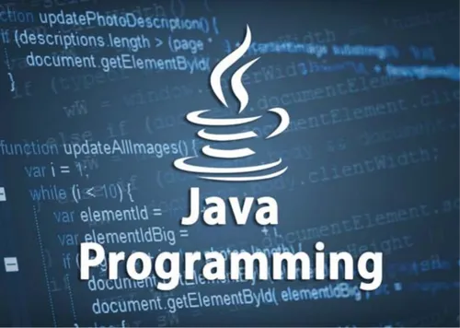

❖ **Key Features:**

1. **Platform Independence:** Java is platform-independent due to the "Write Once, Run Anywhere" (WORA) principle.
2. **Object-Oriented:** Java follows the object-oriented programming (OOP) paradigm, which organizes code into reusable objects and classes.
3. **Robust and Secure:** Java offers strong memory management through automatic garbage collection, reducing memory leaks. Its strict type-checking and runtime error-handling mechanisms make it less prone to crashes.
4. **Simple and Easy to Learn:** Java has a syntax similar to C++, but it's simpler and avoids complexities like pointers and operator overloading.
5. **Multi-threaded:** Java supports multi-threading, enabling developers to create programs that can perform multiple tasks simultaneously, improving performance for parallel processes.
6. **High Performance:** Although Java is not as fast as compiled languages like C++, the Just**-**In-Time (JIT) compiler optimizes bytecode into native machine code at runtime, enhancing performance.
7. **Rich API:** Java provides an extensive set of APIs for various tasks such as data structures, networking, database connectivity, GUI development, and more.
8. **Portable:** Java's architecture-neutral nature ensures portability across different operating systems and hardware environments.

* **Benefits:**

Python is a versatile programming language known for its simplicity, readability, and extensive ecosystem of libraries and frameworks. Here are several key benefits of using Python:

* 1. **\*\*** **Platform Independence: ** Write Once, Run Anywhere (WORA):** Java programs can run on any device with a Java Virtual Machine (JVM), regardless of the underlying hardware or operating system. This reduces the need for re-compilation or platform-specific modifications.
  2. **\*\*** **Object-Oriented Programming (OOP): \*\*** Java's OOP principles make the code modular, reusable, and easier to maintain. Features like encapsulation, inheritance, and polymorphism enhance software design and enable robust development.
  3. **\*\*** **Robust and Reliable: \*\*** Java provides strong memory management and eliminates common errors like pointer misuse. It features automatic garbage collection, exception handling, and type-checking at compile-time and runtime, leading to fewer crashes and bugs.
  4. **\*\*** **Secure: \*\*** Built-in security features include encryption, runtime safety checks, and a restricted execution environment via the Java sandbox. It prevents common vulnerabilities like buffer overflows and unauthorized access.
  5. **\*\*Versatility and Flexibility: ** Java** versatility allows it to be used for a wide range of applications, from scripting and automation to complex web applications and scientific computing. It supports multiple programming paradigms, including procedural, object-oriented, and functional programming styles.
  6. **\*\*Scalability: \*\*** Java is highly scalable, making it suitable for small applications as well as large enterprise-level systems with high performance and reliability**.**
  7. **\*\*** **Performance Optimization: \*\*** Features like the Just-In-Time (JIT) compiler and JVM optimizations ensure high runtime performance. Modern advancements in the JVM make Java suitable even for high-performance computing.
  8. **\*\*** **Multi-threading Support: \*\*** Java allows the development of multithreaded applications, enabling better utilization of CPU resources and faster execution of parallel tasks.
  9. **\*\*** **Easy Integration: \*\*** Java integrates seamlessly with other languages (e.g., Python, C++) via the Java Native Interface (JNI), and with web services and APIs.
  10. **\*\*** **Suitable for Beginner and Expert Developers: \*\*** Withits simple syntax and wide ecosystem, Java is an excellent language for both beginners and seasoned professionals.
* **Applications:**
* Web Development
* Mobile Applications
* Desktop Applications
* Cloud Computing
* Game Development
* Financial and Banking Applications
* Blockchains and Cryptocurrency

***WHY BACK END MYSQL WORKBENCH 8.0 CE***

MySQL Workbench 8.0 CE (Community Edition) is a popular choice for backend development primarily because of its robust features tailored for managing and interacting with MySQL databases. Here are several reasons why MySQL Workbench 8.0 CE is commonly used for backend development:

1. **\*\*Graphical User Interface (GUI): \*\*** MySQL Workbench provides an intuitive graphical interface that allows developers to interact with MySQL databases visually. It offers tools for designing, modelling, and administrating databases, making it easier to manage database structures and relationships.
2. **\*\*Database Design and Modeling: \*\*** It includes features for designing and modeling databases using Entity-Relationship (ER) diagrams. Developers can create tables, define relationships, and visualize database schemas directly within the tool. This helps in planning and optimizing database structures before implementation.
3. **\*\*SQL Development: \*\*** MySQL Workbench includes a SQL Editor with syntax highlighting, code completion, and formatting capabilities. Developers can write and execute SQL queries, stored procedures, and scripts directly within the editor, facilitating database development and testing.
4. **\*\*Performance Monitoring and Optimization: \*\*** The tool offers performance monitoring features to analyze and optimize database performance. Developers can review execution plans, identify bottlenecks, and fine-tune queries for better efficiency.
5. **\*\*Database Administration: \*\*** MySQL Workbench provides administrative tools for managing MySQL server instances, users, and permissions. It allows for backup and restore operations, server configuration,
6. **\*\*Cross-Platform Compatibility: \*\*** MySQL Workbench is available for multiple platforms (Windows, macOS, Linux), ensuring compatibility across different operating systems and environments.
7. **\*\*Integration with MySQL Ecosystem: \*\*** It seamlessly integrates with other MySQL tools and utilities, enhancing workflow efficiency and supporting collaborative development.
8. **\*\*Open Source and Community Support: \*\*** Being part of the MySQL ecosystem and licensed under the GPL, MySQL Workbench benefits from a large community of users and contributors. This ensures ongoing development, updates, and support through forums, documentation, and community resources.

#### SYSTEM DESIGN IMPLEMENTATION OF OUR PROJECT

**\*Implementation: \***

The program was developed using [programming languages/technologies] and follows [specific architecture/framework].

• **+-Key modules include:**

* **\*Database Management: \*** Utilizes [database system] to store and retrieve patient information securely.
* **\*User Interface: \*** Designed with a user-friendly interface to facilitate easy navigation and data entry.
* **\*Security Features: \*** Implements encryption protocols and access controls to protect patient confidentiality.

❖ **JAVA INSTALLATION:**

➢ **Installing Java on Windows:**

1. **Download Java Installer:**

o Visit the official Oracle Java website: oracle.com/in/java/[.](https://www.python.org/downloads/) o Navigate to the Downloads section and choose the latest version of Java for Windows.

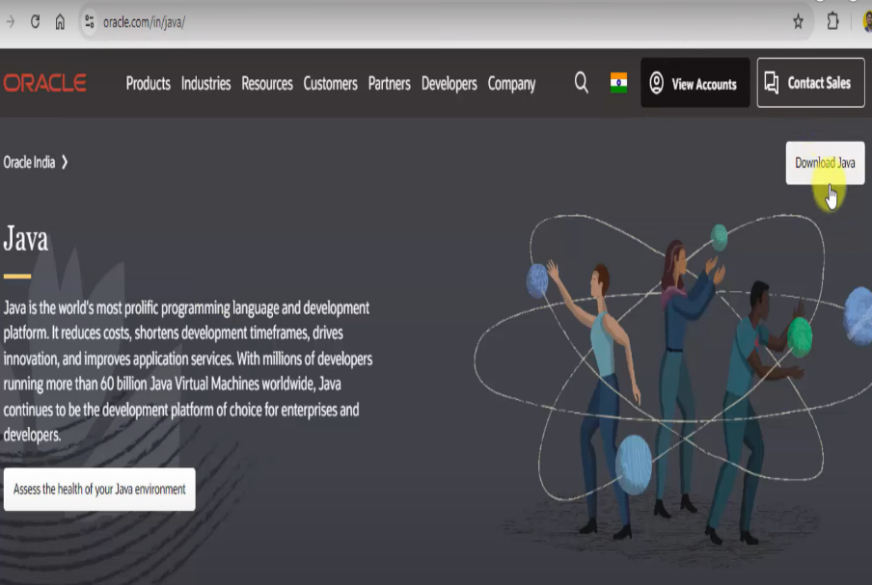

##### Figure:2.1

2. **Run the Installer:**

o Once the installer is downloaded, run it by double-clicking the downloaded file.

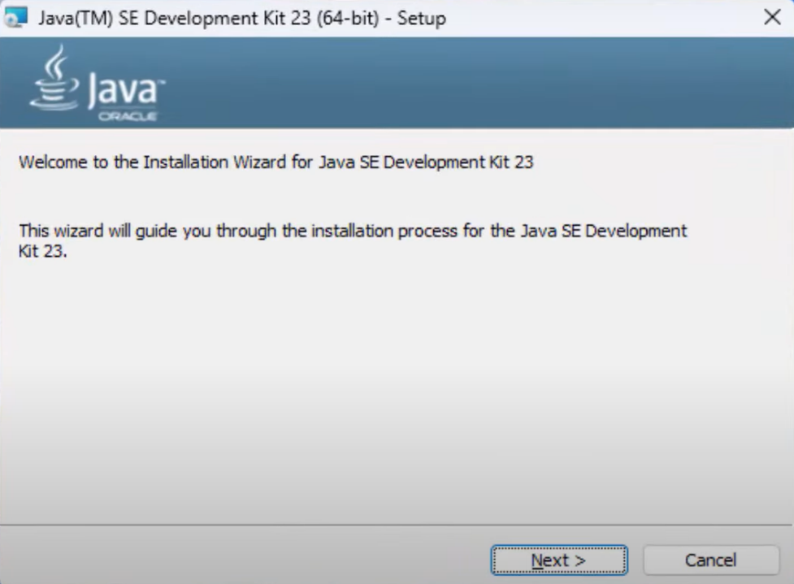

##### Figure:2.2

3. **Configure Java Installation:**

Click on "Install Now" to start the installation.

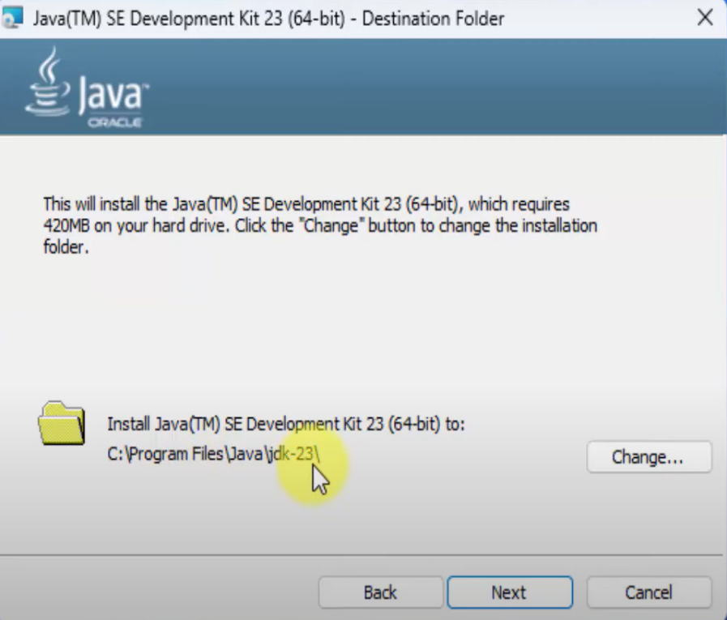

##### Figure:2.3

4. **Complete Installation:**

o the installer will install Java and its associated tools. Once complete, you should see a message indicating that Java was successfully installed.

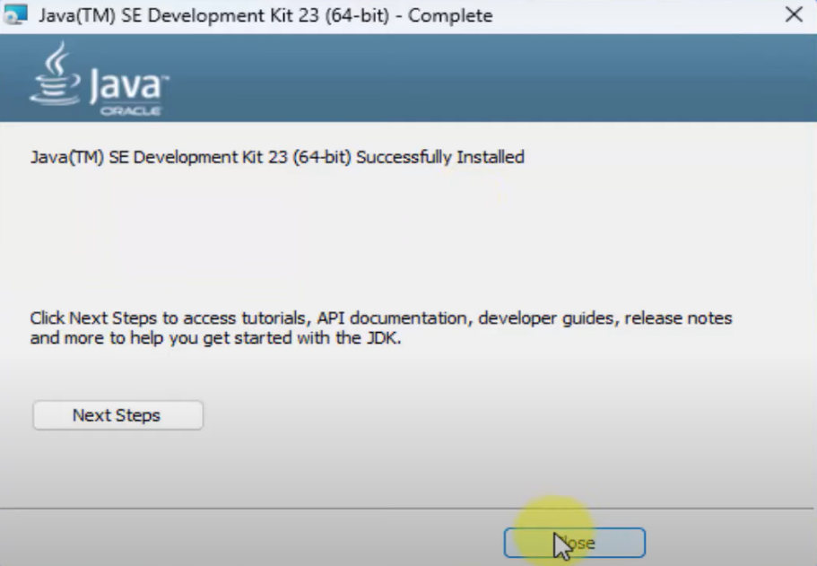

##### Figure:2.4

5. **Verify Installation:**

o Open a command prompt (cmd) and type java --version or java -V to verify that Java is installed and to see the version number.

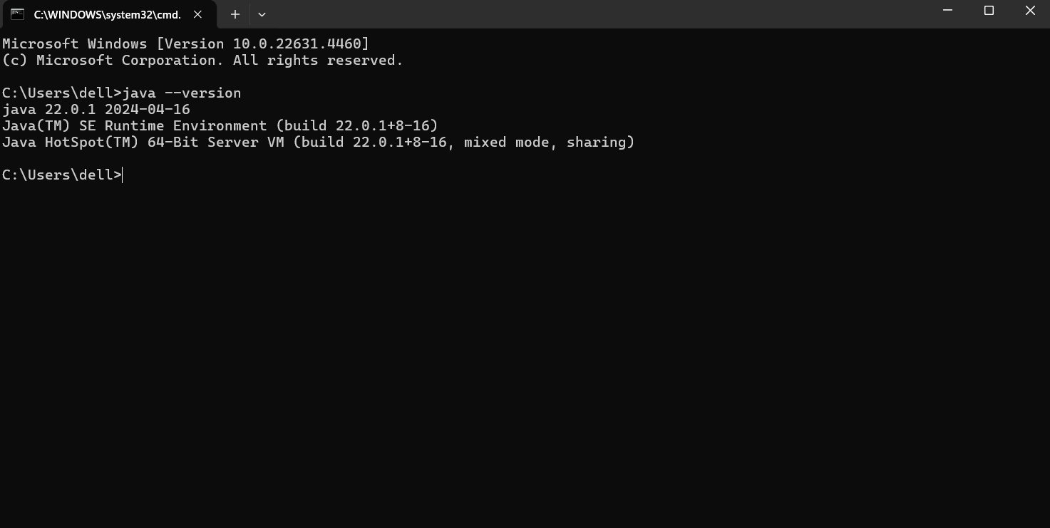

##### Figure:2.5

➢ **Java System.out.print():**

In Java, the System.out.print and System.out.println methods are used to print messages to the console.

For Example:

public class Main {

public static void main (String [] args) {

System.out.println("Welcome to Java Programming!");

}

}

OUTPUT: Welcome to Java Programming!

➢ **Java Conditional Statements:**

Conditional statements in Java control the flow of execution based on conditions. They allow you to execute specific blocks of code when certain conditions are met. Here’s an overview of the conditional statements in Java:

Int number = 0;

If (number > 0) {  
System.out.println(“Positive Number”);

} else if (number < 0) {  
System.out.println(“Negative Number”);

} else {  
System.out.println(“Zero”);

}

##### **#**Java Loops

Java has two primitive loop commands:

* **while loop: -**

int i = 0;

while (i< 5) {  
 System.out.println("Iteration: " + i);

i++;

}

OUTPUT:

0

1

2

3

4

* **for loop: -**

For example:

for (int i = 0; i < 5; i++) {

System.out.println("Iteration: " + i);

}

OUTPUT:

0

1

2

3

4

* **do-while loop: -**

int i = 0;

do {

System.out.println("Iteration: " + i); i++;

}

while (i < 5);

OUTPUT:

0

1

2

3

4

* **nested loop: -**

for (int i = 1; i <= 3; i++) {

for (int j = 1; j <= 3; j++) {

System.out.println("i: " + i + ", j: " + j);

}

}

OUTPUT:

i: 1, j: 1

i: 1, j: 2

i: 1, j: 3

i: 2, j: 1

i: 2, j: 2

i: 2, j: 3

i: 3, j: 1

i: 3, j: 2

i: 3, j: 3

* **Creating a Function**

In Java, a function (commonly called a method) is a reusable block of code designed to perform a specific task.

For Example:

public class Main {

public static void greet () {

System.out.println("Welcome to Java programming!");

}

public static void main (String [] args) {

greet ();

}

}

OUTPUT:

Welcome to Java programming!

* **Java Classes/Objects**
* Java is an object-oriented programming language.
* Almost everything in Java is an object, with its properties and methods.
* A Class is like an object constructor, or a "blueprint" for creating objects.
* Objects can also contain methods. Methods in objects are functions that belong to the object.
* Classes can inherit attributes and behaviours from another class using the extends keyword.
* Objects are created using the new keyword followed by the class constructor...
* Fields store the data or state of an object. They are defined inside the class.

For Example:

class Car {

String brand;

int year;

Car (String brand, int year) {

this. brand = brand;

this. year = year;

}

void displayInfo () {

System.out.println("Brand: " + brand + ", Year: " + year);

}

}

OUTPUT:

Brand: brand , Year: year

➢ **What is JDK in Java?**

The Java Development Kit (JDK) is a software development environment used to develop Java applications. It is a critical component of the Java ecosystem, providing all the tools, libraries, and resources needed for Java programming.

**#JDK vs JRE**

• JDK (Java Development Kit**)**: Used for developing and running Java programs. It includes the JRE and additional tools like a compiler and debugger.

• JRE (Java Runtime Environment): Used only for running Java programs. It includes the JVM and runtime libraries but lacks development tools.

➢ **Why is JDK Important?**

The JDK is essential for Java developers because it provides everything needed to write, compile, debug, and run Java programs. It is the starting point for learning and working with Java.

• **Install JDK:**

Download the JDK from Oracle's website or OpenJDK.

Install it and configure the environment variable (JAVA_HOME) to point to the JDK directory.

➢ **Exception Handling:**

* A try block contains the code that might throw an exception. The catch block handles the exception.
* The try block contains code that might throw an exception.
* The catch block handles the exception if one is thrown.
* Finally block executes code (like resource cleanup) regardless of an exception.
* Throw block used to explicitly throw an exception.

For Example:

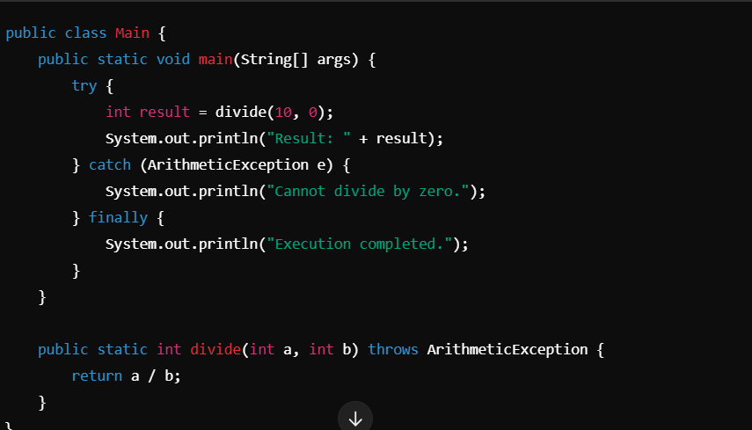

###### Figure:2.9

❖ **MYSQL INSTALLATION:**

➢ **Installing MySQL on Windows:**

1. **Download MySQL Installer:**

* Visit the MySQL Community Downloads page: [MySQL Community Downloads.](https://dev.mysql.com/downloads/mysql/)
* Download the MySQL Installer appropriate for Windows.

###### Figure:3.1

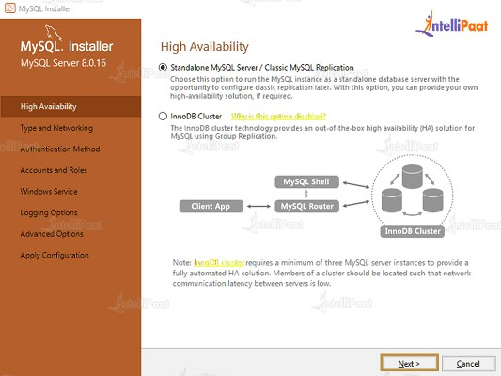

1. **Run the Installer:**
   * Once downloaded, double-click the installer file (e.g., mysql-installer-community8.0.xx.xxx.msi) to launch the MySQL Installer.
2. **Choose Setup Type:**
   * Select "Developer Default" setup type, which installs MySQL Server, MySQL Workbench (optional GUI tool), connectors, and other tools recommended for development purposes. o Alternatively, you can choose "Custom" to customize the installation components according to your requirements.
3. **Installation Process:**
   * Follow the prompts in the MySQL Installer wizard to proceed with the installation.
   * Configure MySQL Server settings such as port number, root password, and service configuration during the installation process.
4. **Complete Installation:**
   * Once installation completes, click "Finish" to exit the installer.

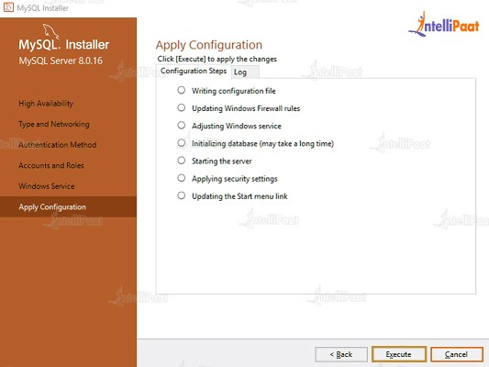

###### Figure:3.2

6. **Verify MySQL Installation:**

o Open MySQL Workbench or a command prompt and connect to the MySQL server using the root username and password configured during installation. o You can also check the MySQL service status in Windows Services (services. MSc).

➢ **Installing MySQL Workbench 8.0 CE on Windows:**

1. **Download MySQL Workbench Installer:**
   * Visit the MySQL Workbench download page: MySQL Workbench Download.
   * Choose the appropriate installer for Windows (typically a .msi file).

1. **Run the Installer:**
   * Once the installer is downloaded, double-click the file (e.g., mysql-workbenchcommunity-8.0.xx-windows-x64.msi) to launch the installation wizard.

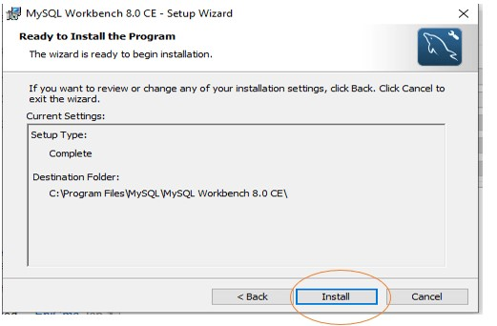

###### Figure:4.1

3. **Setup Wizard:**

* Follow the prompts in the MySQL Workbench Setup Wizard.
* 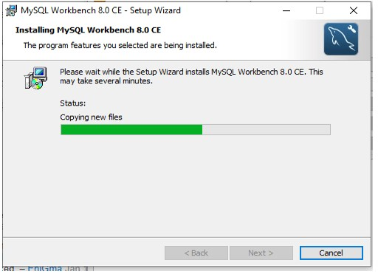
* Click "Next" to proceed through the steps.

1. **Choose Installation Type:**
   * Select "Complete" to install MySQL Workbench with all features, including MySQL Utilities and sample models, or choose "Custom" to customize the installation.

1. **Install MySQL Workbench:** o Click "Install" to begin the installation process.
   * If prompted, confirm any User Account Control (UAC) requests.

1. **Complete Installation:**
   * Once the installation completes, click "Finish" to exit the installer.

1. **Launch MySQL Workbench:** o MySQL Workbench should be accessible from the Start Menu or desktop shortcut.

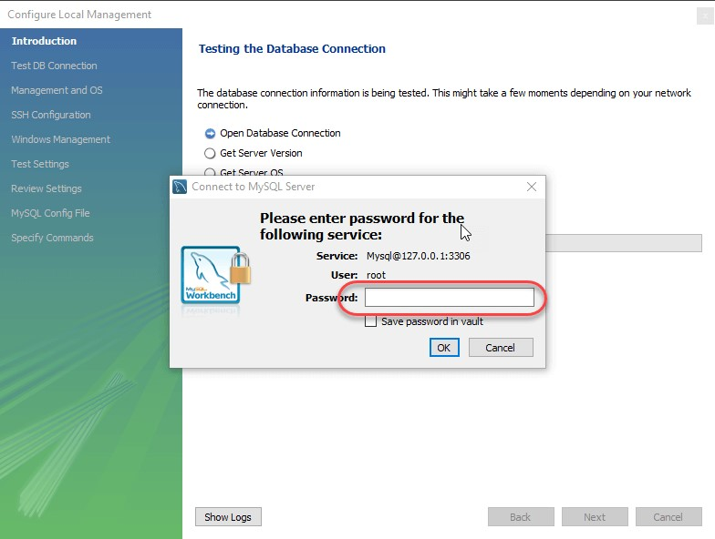

###### Figure:4.3

**CODING**

**Home page source code :**

package com.project;

import java.awt.Font;

import java.awt.event.ActionEvent;

import java.awt.event.ActionListener;

import javax.swing.*;

public class HomePage {

public static JFrame frame;

public static void main(String[] args) {

frame = new JFrame("Library Management System");

JPanel panel = new JPanel();

JLabel LMS = new JLabel("LR Engineering & Technology Library");

LMS.setFont(new Font("tahoma", Font.BOLD, 20));

JButton adminlogin = new JButton("Admin Login");

adminlogin.addActionListener(new ActionListener() {

public void actionPerformed(ActionEvent e) {

AdminLogin adminlogin1 = new AdminLogin();

adminlogin1.frame1.setVisible(true);

}

});

JButton librarianlogin = new JButton("Librarian Login");

librarianlogin.addActionListener(new ActionListener() {

public void actionPerformed(ActionEvent e) {

LibrarianLogin librarianlogin = new LibrarianLogin();

librarianlogin.frame6.setVisible(true);

}

});

panel.add(LMS);

panel.add(adminlogin);

panel.add(librarianlogin);

frame.add(panel);

frame.setSize(400,400);

frame.setDefaultCloseOperation(JFrame.EXIT_ON_CLOSE);

frame.setVisible(true);

}

}

**Whole code is available on this github account :**

Github profile link:- <https://github.com/AnkushLagwal>

**SNAPSHOTS**

1. **Login Screen:**
   * Secure admin authentication.

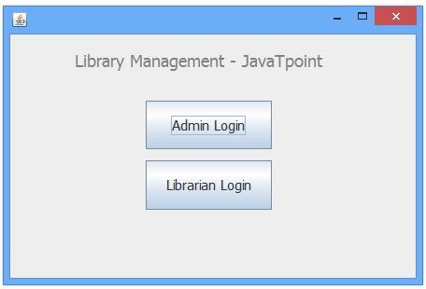

1. **Librarian Management:**
   * Add, update, and delete librarian records.

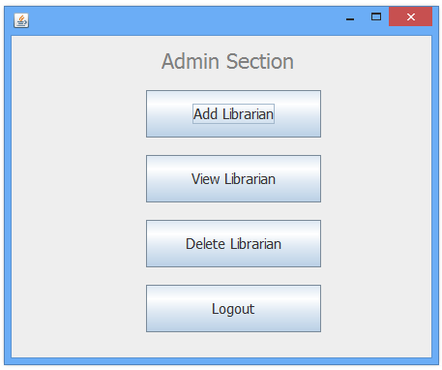

1. **Book Inventory Management:**
   * Add new books, view inventory, and dynamically update details.

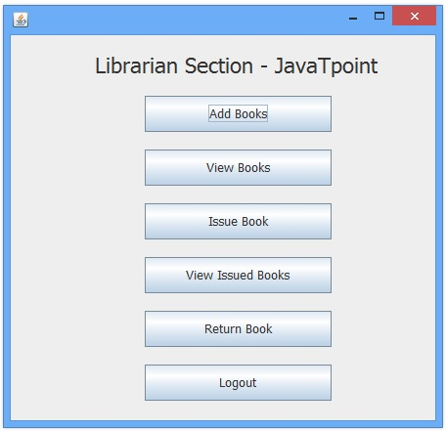

1. **Issue and Return Management:**
   * Interface for issuing and returning books.

## ****SCOPE OF THE PROJECT****

* Target Audience: Small and medium-sized libraries.
* Functionalities:
  + Librarian management.
  + Book inventory management.
  + Issuance and return processes.
* Future Enhancements:
  + Member management.
  + Advanced reporting.

**BIBLIOGRAPHY**

* <https://www.oracle.com/in/java/>
* [www.w3schools.com](http://www.w3schools.com/)
* [www.geeksforgeeks.org](http://www.geeksforgeeks.org/)
* [www.researchgate.net](http://www.researchgate.net/)
* [www.piecex.com](http://www.piecex.com/)